The First World Landslide Forum 2008

Title of Presentation | Landslide hazard assessment, vulnerability estimation, and risk evaluation at the basin scale.
Name of presenter | Paola Reichenbach
Name of Organization | CNR IRPI
Number & Title of the first preferred session | Session n. 12, Mapping: Inventories, Susceptibility, hazard and Risk
Number & Title of the second preferred session
Date of Submission

Landslide hazard assessment, vulnerability estimation, and risk evaluation at the basin scale.
Francesca Ardizzone, Mauro Cardinali, Fausto Guzzetti, Paola Reichenbach
CNR IRPI, via Madonna Alta 126, 06128 Perugia, Italy

The ultimate goal of many landslide studies is the determination of the risk posed by existing or future slope failures. To achieve this goal, information on landslide hazard and vulnerability to landslides is required. For the Collazzone area, central Umbria, landslide hazard was ascertained, landslide vulnerability was determined, and landslide risk was evaluated, for different scenarios. To ascertain landslide hazard, a specific probabilistic model was adopted to predicts where landslides will occur, how frequently they will occur, and how large they will be in a given area. A multi-temporal landslide inventory map was prepared through the interpretation of five sets of aerial photographs covering the period from 1941 to 1997, and field surveys in the period from 1997 to 2004. A 10 m × 10 m digital representation of the topography (DEM) was used to partition the study area into 894 slope units. For each slope unit: (i) the probability of spatial landslide occurrence was obtained through discriminant analysis of a large set of thematic and environmental variables; (ii) the probability of experiencing one or more landslides in different periods was determined adopting a Poisson probability model for the temporal occurrence of landslides, and (iii) the probability of landslide size was obtained by analyzing the frequency-area statistics of landslides. Assuming independence of the three computed probabilities, landslide hazard was determined as the joint probability of landslide size, of landslide temporal occurrence, and of landslide spatial occurrence. The maps shown in Figure 1 portray landslide hazard in the Collazzone area for four different periods and for landslides of two size classes.
Information on the vulnerability to landslides is lacking almost everywhere, hampering our ability to evaluate risk. For the Umbria region, landslide vulnerability curves were established exploiting information on landslide damage to buildings and roads caused by individual landslides of the slide type in the 24-year period between 1982 and 2005. Empirical observations revealed that, in Umbria, the proportion of direct damage caused to buildings and roads by slides and slide-earth flows depends on the area of the damaging landslide. As a first approximation, the direct damage caused by a slope failure increases with the area of the hazardous landslide. However, the proportion of the damage does not scale linearly with the area, complicating the assessment of landslide vulnerability. Minimum and maximum vulnerability curves were established for roads in Umbria and were used to map the expected vulnerability of the road network to landslides in the Collazzone area.
Assuming independence of hazard and vulnerability, and exploiting (i) the multi-temporal landslide inventory map, (ii) the obtained landslide hazard assessment, and (iii) the available landslide vulnerability curves, landslide risk to the road network was evaluated in the Collazzone area, for different scenarios. Results indicate that landslide risk can be determined quantitatively over large areas, provided adequate forecasting models are adopted and reliable landslide and thematic information is available.

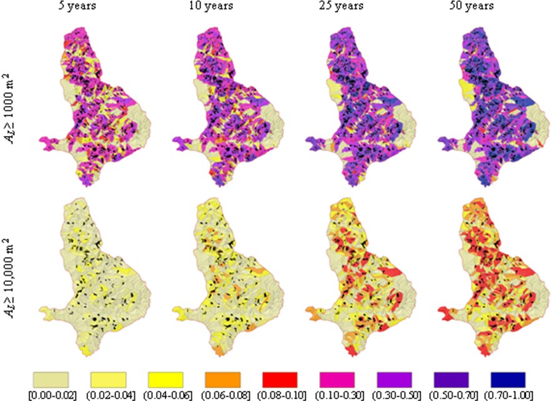
Figure 1. Landslide hazard scenarios for four periods, from 5 to 50 years, and for two classes of landslide size, A_{L} ≥ 1000 m² and A_{L} ≥ 10,000 m². Colours show landslide hazard i.e., the joint probability of landslide size, of landslide temporal occurrence, and of landslide spatial occurrence.

