The First World Landslide Forum 2008

Title of Presentation | Exploiting Earth Observation Technology to Map, Monitor and Forecast Landslides: the ASI MORFEO Project
Name of presenter | Fausto Guzzetti
Name of Organization | CNR IRPI
Number & Title of the first preferred session | Session n. 1. A look from space
Number & Title of the second preferred session | Session n. 13. Monitoring, Prediction and Early Warning
Date of Submission

Exploiting Earth Observation Technology to Map, Monitor and Forecast Landslides: the ASI MORFEO Project
Fausto Guzzetti¹, Laura Candela², Roberto Carlà¹, Gianfranco Fornaro¹, Riccardo Lanari¹, Giovanna Ober³
(1) Consiglio Nazionale delle Ricerche, (2) Agenzia Spaziale Italiana, (3) Carlo Gavazzi Space

Advances in space borne, airborne and terrestrial remote sensing technologies have improved our ability to identify, map, and monitor ground deformations, including landslides. In 2001, the Italian Space Agency (ASI) launched a multifaceted call for technological and scientific applications of remote sensing technology to help identify, monitor, forecast, and mitigate natural and manmade hazards, including slope failures. In 2007, ASI lunched the MORFEO project, a coordinated research and development initiative aimed at the development and preliminary implementation of a prototype system to support the Italian National Civil Defence Department activities on landslide risk assessment and mitigation.
MORFEO, an Italian acronym for Monitoring Landslide Risk through Earth Observation technology, is a three-year project aimed at the exploitation of Earth observation (EO) data and technologies, consolidated and innovative ground-based monitoring tools, and existing and new thematic and environmental information, to improve the ability of the Italian National Civil Defence Department to promptly identify, map, monitor, and forecast landslides of different types, and in different physiographic environments. For the purpose, MORFEO implements five functionalities of interest for landslide civil defence:
- Identification and mapping of landslides, at different geographical scales, through the exploitation of state-of-the-art EO data and technologies, including the dynamic 3-dimensional visualization of landslide areas captured by high and very high resolution satellite optical sensors.
- Landslide monitoring, through the integration of state-of-the-art observation technologies, including satellite and ground-based DInSAR and GPS, for monitoring known landslides, and for the rapid identification of new or incipient movements of natural and manmade slopes.
- Landslide susceptibility, hazard, and risk modelling at different geographical scales and for different landslide types, through the use of original models that incorporate information derived from high and very high resolution satellite optical and radar images.
- Forecasting of rainfall induced landslides, through models and thresholds and the exploitation of existing landslide information, quantitative rainfall forecasts, precipitation measurements obtained from networks of rain gauges and weather radars, and estimates of rainfall obtained from meteorological satellites.
- Landslide vulnerability and damage assessment, through the design of event scenarios constructed exploiting existing high resolution landslide, topographic and thematic data, and high and very high resolution satellite optical and radar images.
Scientists and engineers working within the MORFEO project will be amongst the first to receive and test data acquired by the ASI COSMO-SkyMed constellation of satellites, equipped with radar sensors that can operate with very short revisiting times. Using this unique constellation of SAR sensors, state-of-the-art DInSAR techniques to monitor slope failures in urban areas and to evaluate the stability of large manmade slopes and embankments will be exploited.
The MORFEO team is headed by Carlo Gavazzi Space (CGS), a leading European company in space technology, and by IRPI, a research institute of the Italian National Research Council leader in landslide investigations. CGS and IRPI are assisted by a unique multi-disciplinary team comprising research institutes, university departments and Italian enterprises collectively experts in landslide identification and mapping, slope monitoring, landslide and environmental hazard and risk assessment and mitigation, and in the innovative exploitation of EO data and technologies. MORFEO is characterized by a significant research component, in terms of institutions involved and planned activities. Innovative research is a key aspect of the project because of the challenging task to successfully exploit multiple satellite, airborne, and ground based EO technologies for landslide risk assessment and mitigation.
The following two figures (Figure 1 and Figure 2) show preliminary results obtained by partners of the MORFEO team. Figure 1, obtained by CNR IFAC, shows 3D-views of the Sarno area, Campania region, affected by multiple catastrophic debris flows on 5 May 1997. Figure 1A shows a high altitude, colour aerial photograph taken shortly after the event. Figure 1B shows a very high resolution satellite image acquired on July 1999. Analysis of the images indicates that combined state-of-the-art optical remote sensing and dynamic visualization technologies can be used to identify and map landslides effectively. Figure 2, prepared by CNR IREA and IRPI, shows surface deformation rate maps in an area of the Assisi Municipality, central Italy, affected by a deep-seated, slow moving landslide. The low resolution (left) and high resolution (right) maps cover the 9-year period from 1992 to 2000, and were obtained processing SAR data acquired by the European Remote Sensing (ERS-1 and ERS-2) satellites along descending orbits. Inspection of the maps reveals a good agreement between the measured surface deformation and the available information on the location and extent of the landslide. This confirms the effectiveness of the space-borne DInSAR technology to investigate slow moving urbanized landslides in selected areas.

(A) | (B)
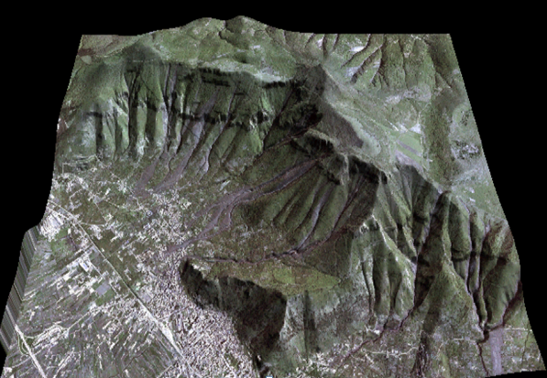 | 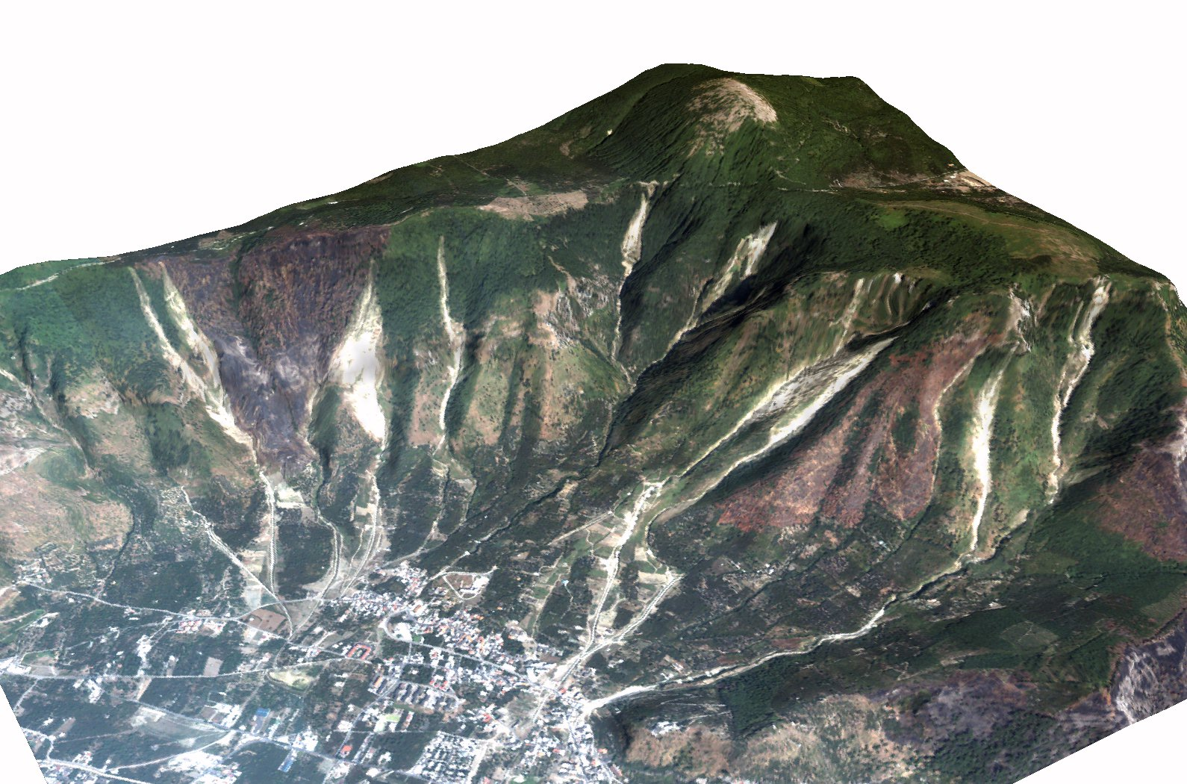
Figure 1. 3D-views of the Sarno area, Campania region, affected by multiple catastrophic debris flows on 5 May 1997. (A) high altitude colour aerial photograph. (B) very high resolution satellite image.

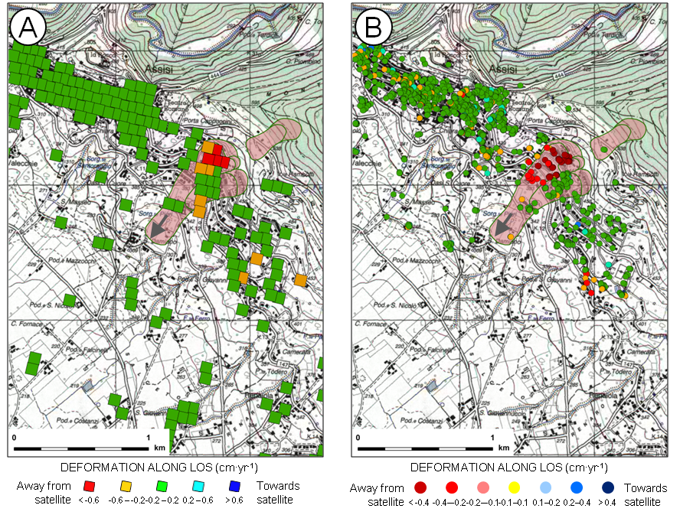
Figure 2. Surface deformation rate maps for the Ivancich landslide area, Assisi Municipality, Italy, in the period from 1992 to 2000. (A) Low resolution deformation rate map. (B) High resolution deformation rate map. Pink areas show known landslides. Gray arrow shows landslide main direction of motion.

