
Ivan Marchesini*⁽¹⁾, Michele Santangelo^{(1,2)}, Federica Fiorucci^{(1,2)}, Mauro Cardinali⁽¹⁾, Mauro Rossi⁽¹⁾, Fausto Guzzetti⁽¹⁾
A GIS method for obtaining geologic bedding attitude
- I.R.P.I. – C.N.R., Via Madonna Alta 126, Perugia, Italy.
- Dipartimento di Scienze della Terra, Università degli Studi di Perugia, Piazza dell’Università 1, Perugia, Italy.
- Corresponding author: Ivan.Marchesini@irpi.cnr.it

Abstract Landslide susceptibility assessment at different scales and in different physiographic environments, requires quantitative information on multiple thematic environmental data. Information on bedding attitude proves necessary to define the structural and geological setting of an area. In this study, we developed a procedure to obtain bedding attitude data exploiting aerial photo-interpretation and a GRASS GIS script. Results show that our procedure provides bedding attitude information in good agreement with data acquired during field surveys. We foresee the possibility to generate dense spatial distributions of bedding attitude data, useful for spatial interpolation and landslide susceptibility assessments.

Keywords landslides, susceptibility, bedding attitude, GIS, aerial photo-interpretation.

Introduction
Bedding attitude (BA) information is useful to define the structural and geological setting of an area, and is important for the determination of landslide susceptibility (Guzzetti et. al., 2006). BA can be defined as the spatial arrangement of the bedding planes, and is commonly expressed by dip direction and dip angle (inclination) values. Bedding attitude measurements can be collected during structural surveys, or through the interpretation of aerial photographs (API). The first method provides quantitative local (point) measures of BA that may not be representative of the regional structural setting. The second method provides semi-quantitative BA information representative of a general geological and structural arrangement, suitable for medium- to small-scale assessments.
The intersection line between a bedding plane and topography (i.e., the bedding trace, BT) allows to (i) infer the bedding surface (BS), the flat surface that locally approximates the bedding plane, and (ii) estimate the BA (Fig. 1). The method is known as “structure contours” (e.g. Rowland & Duebendorfer, 1994). In the literature, little exists on the development of systems to exploit GIS methods and API to obtain quantitative BA information (Cardinali et al., 2001). For the purpose, we present a procedure in two steps: (i) a preliminary API of an image dataset, performed by trained geomorphologists, and (ii) the subsequent processing of BTs through a script implemented in a GIS environment.

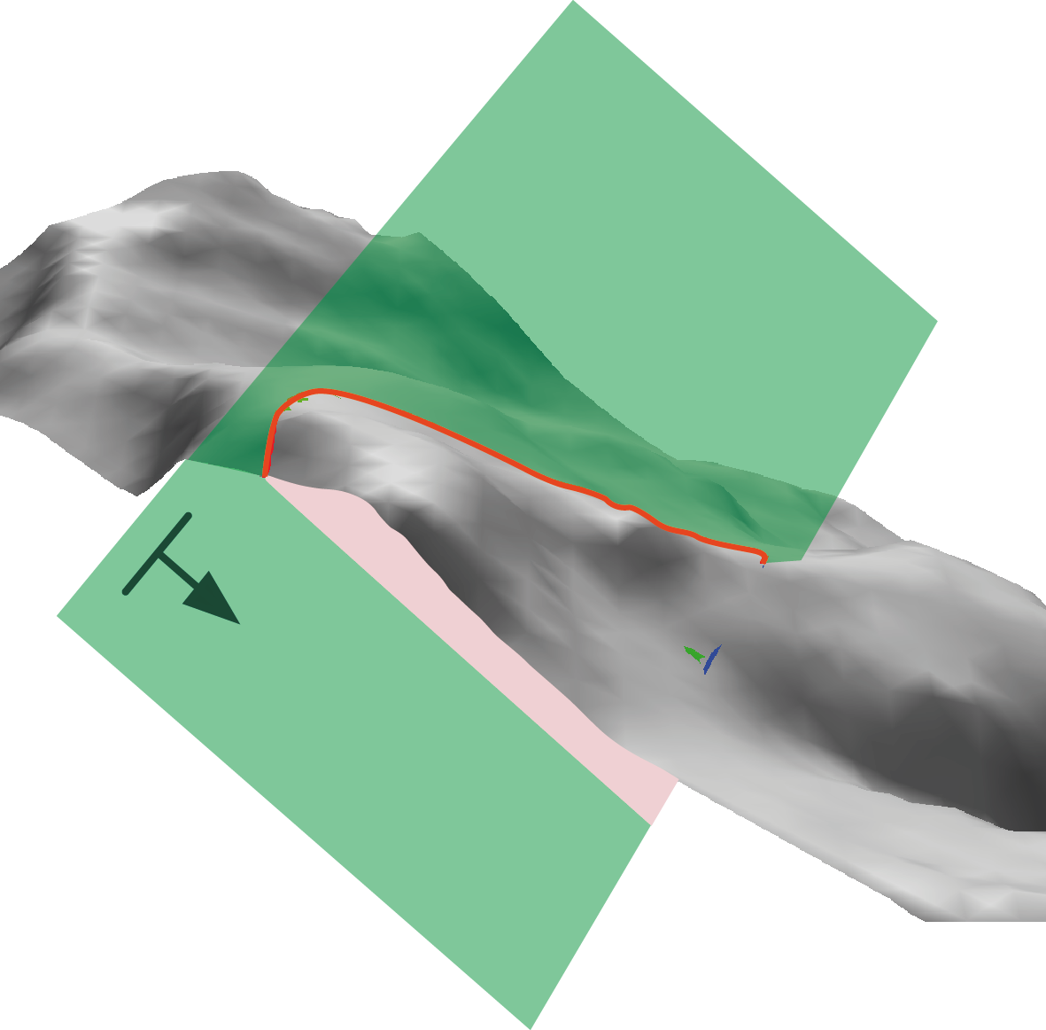
Figure 1 Example of bedding trace (BT, red line), bedding surface (BS, green plane), and bedding attitude (BA, symbol with arrow).
Materials and Methods
Bedding trace mapping
API criteria to detect and map bedding traces (BTs) are based mainly on the morphoselection principle. Sequences of rock layers with different strength, grain size, and mineralogical composition, have a distinct morphological and photographic signature. Such characteristics are shown in stereoscopic aerial photographs. Hence, a trained geomorphologist is capable to detect the BTs, and to define the related qualitative BAs. In particular, BTs can be identified by photographic and morphological elements such as: (i) sub-parallel bands having different colour tones in unvegetated areas, (ii) the presence of sub-parallel vegetation bands, (iii) the repetitive variations in terrain gradient along a slope, and (iv) geomorphological considerations on the asymmetry of a relief.
The vertical exaggeration typical of stereoscopic view allows detecting very subtle morphological features. Fig. 2a shows a 2D view of a satellite image where BTs are represented by numerous sub-parallel linear bands of different shades of colour. In the 3D image (Fig. 2b), the intersection of BTs with topography provides clear information on BAs.

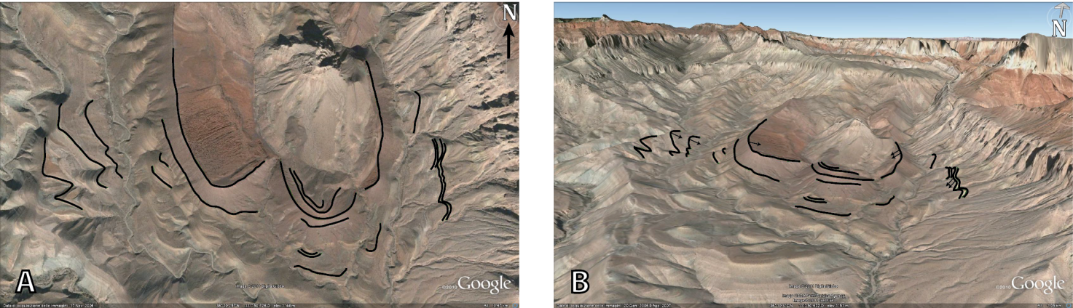
Figure 2 Example of bedding traces detected by photointerpretation criteria on a GoogleEarth image of Grand Canyon, (AZ). The BTs are recognizable even by photographic elements alone (a). The three-dimensional view emphasizes the intersection of the same BTs with topography and allows to estimate the dip and dip direction of bedding planes (BA) (b).

Bedding attitude estimation
We implemented a GIS tool using shell scripting in GRASS GIS environment (GRASS Development Team, 2010) and GNU-Linux OS. The script returns a vector map of points whose attributes contain information on dip angle, dip direction, and associated uncertainty. A BTs map (represented by open and closed lines), and a DEM are necessary to execute the code.
The script is in five steps, which are replicated for each BT. In the first step, the BT is draped on the DEM becoming a 3D linear feature (Fig. 3a). If the BT is an open line, (second step) the script draws a three-dimensional segment to join the two end nodes of the line representing the BT (Fig. 3b). The new line ad the BT form a polygon. In the third step, the 3D polygon boundary is sampled to obtain a sequence of regularly spaced points. Point spacing depends on the resolution of the DEM. A 3D Delaunay triangulation (Davis, 1973) is then performed. The Delaunay triangulation method was selected because it limits user subjectivity. The result is a nearly flat surface corresponding to the BS (Fig. 3c and 4a). The fourth step consists in calculating the BS slope (Fig. 4b) and aspect (Fig. 4c) raster maps. The mean values for the dip and the dip direction of the BS are estimated in the fifth step. The average BS inclination is the median of the slope map values. Then, the standard deviation (a measure of uncertainty) of the slope map is calculated.
Average BS dip direction is calculated following the method proposed by Davis (1973). Sine and cosine of the aspect map are calculated. The average aspect (dip direction) of the BS is determined using mean sine and cosine values. The statistical spread of the dip direction is calculated in two methods. In the first method, circular variance (V) is calculated as:
$$V=\frac{1−R}{n}$$
where n is the number of cells of the BS aspect map, and R is the modulus of the resultant vector of the unitary vectors of each aspect map cell. V can take values in the range from 0 to 1. Low V values indicate a nearly flat surface, and higher values indicate a steep surface (Davis, 1973; Nichols, 2009). The second method estimates the angular standard deviation of the aspect map as (Butler, 1992):

$$\text{S=}\frac{1}{(\text{n-1})}\sum_{i=1}^{n}{Δ_{i}^{2}}$$
where, $Δ_{i}$ is the angle between the aspect of the i-th cell and the average aspect, and n is the number of the aspect map cells.

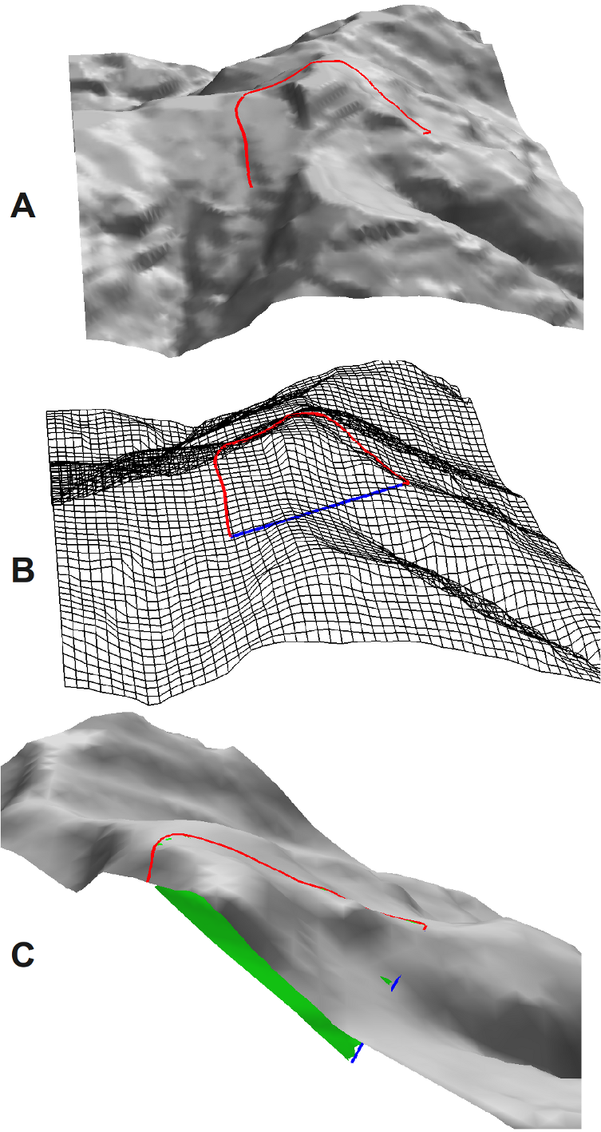
Figure 3 A: Bedding trace draped on the DEM, B: bedding trace nodes joining, C: bedding surface (BS) is drawn in green.
All the values (i.e. median slope, slope standard deviation, average aspect, circular variance, angular standard deviation) are assigned to a BA point-vector layer. Each point in the layer is the centroid of the bounding box of the corresponding BT.

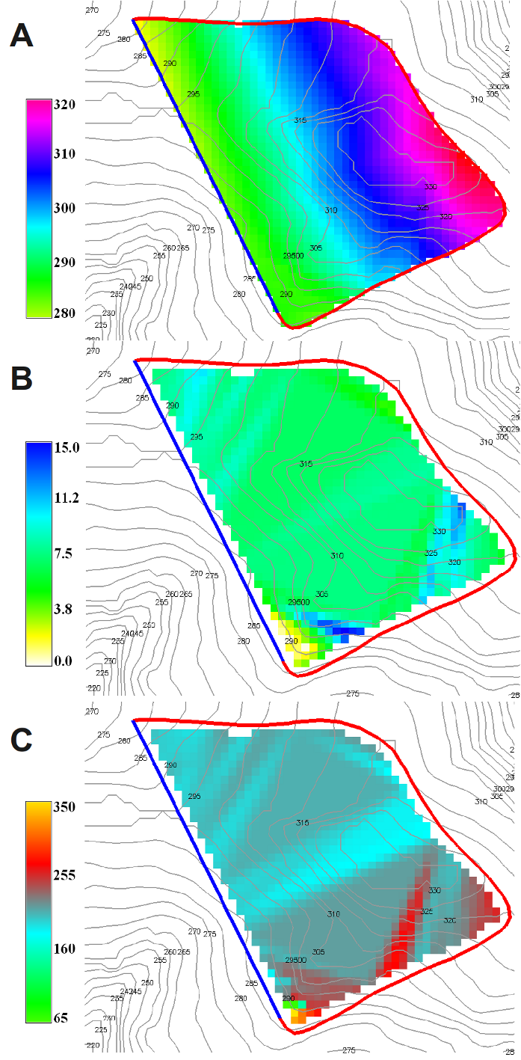
Figure 3 A: BS elevation map (meters a.s.l.), B: BS slope map (degrees), C: BS aspect map (degrees, CCW from east).

Results
We tested the procedure in the Collazzone study area, Umbria, central Italy. Two geomorphologists interpreted stereoscopic b/w aerial photographs taken at 1:33.000 scale in 1954. The images proved effective for the analysis because forest cover was sparse at the time of the photographs, allowing for the recognition of geomorphological features even in forested areas. The bedding traces (BTs) were drawn on a transparent film superimposed on the aerial photographs.
In a second step, the mapped features were visually transferred (re-drawn) on a transparent non-deformable plastic sheet superimposed on a 1:10,000 scale topographic base map. Then, the transparent sheet was scanned and geo-referenced to enable digitization and storage of the information in a GIS vector layer. When transferring the information from the aerial photographs to the GIS dataset, errors can occur due to e.g.: (i) the change in scale, from the smaller scale of the aerial photographs (1:33,000) to the larger scale of the topographic map (1:10,000 scale), (ii) object deformation on the stereoscopic model, due to the vertical exaggeration and the conical projection of the aerial photographs, (iii) differences in topography in the different cartographic media (aerial photographs and base maps (Ardizzone et al., 2007), (v) the absence in the topographic base map of BTs’ photographic elements. This results in mapping errors (positioning and shape) of the single BT.
After API, the GRASS script was executed obtaining a preliminary BAs layer. The layer was then analysed by the geomorphologists to identify BTs that needed corrections. We used a 3D digital model obtained from a pair of stereoscopic VHR satellite images taken by the GeoEye satellite in May 2010. The three-dimensional BTs were superimposed to the oriented stereoscopic model, and the error corrected. Where necessary, new 3D BTs were digitized directly on the oriented stereo pair. Finally, a second run of the script was executed using the revised BTs dataset to produce a new BA layer. Fig. 5 shows details of the obtained BA map. In the Figure BAs are represented by oriented symbols, scaled to the inclination value.
Bedding inclination spans the range from 1° (small bedding symbol) to 20° (large bedding symbol). The angular standard deviation (S) is less than 16° for half of the BAs dataset, and less than 30° for 75% of the BA data. Most of the BAs that have high values of S are characterized by low values of the mean slope (sub-horizontal layers, see chart in Fig. 6). This explains the strong directional variability. Inclination values are less scattered. About 75% of the values of the dip standard deviation are smaller than 2°, with a maximum value of 8°.

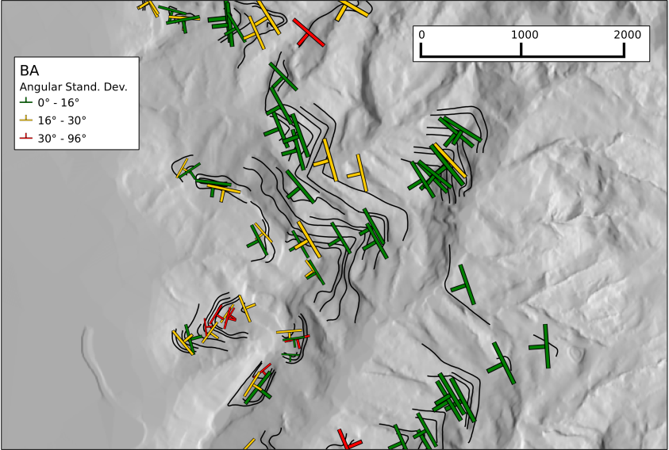
Figure 4 BAs can be represented by means of oriented symbols (according to dip direction), different dimensions (proportional to the inclination value), and different colours (according to three different levels of dip direction angular variance).
A quality assessment of the results obtained was performed through a visual inspection carried out by the same geomorphologists who performed the API. The representation, with colours and oriented symbols, has proved particularly useful in facilitating the verification of the degree of matching between BAs and the geomorphologists’ expectations.
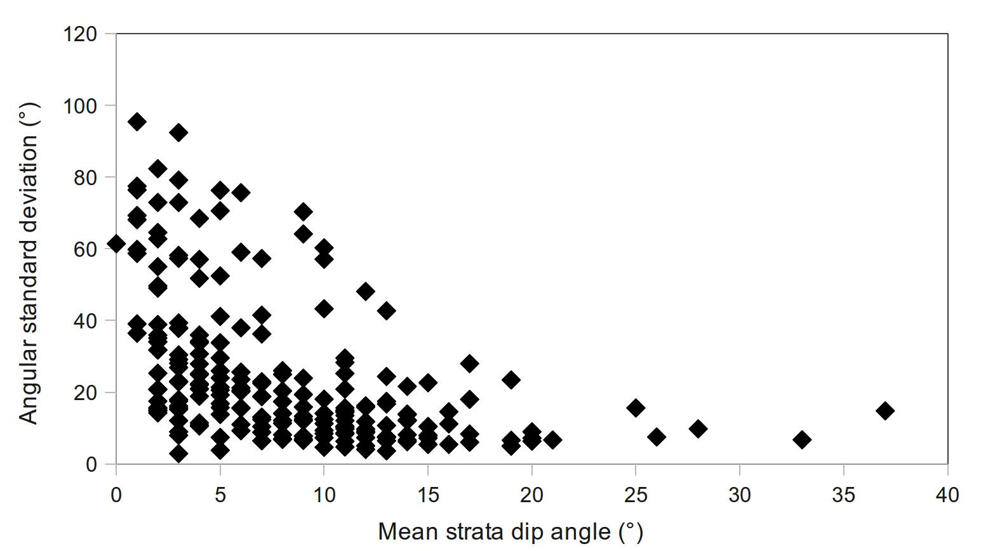
Figure 5 The graph shows the BSs angular standard deviation against the mean inclination of the BSs for the Collazzone BTs dataset. The angular standard deviation (V) of the BSs dip direction is generally high only when the BSs dip is low.

The obtained BA data (red symbols in Fig. 7) were further compared to data obtained during geological field surveys (yellow symbols in Fig. 7). Visual comparison of the two datasets indicates that the BAs obtained through the API and GIS procedure are more widespread and consistent with the dominant structures in the study area (a syncline is highlighted in Fig. 7).

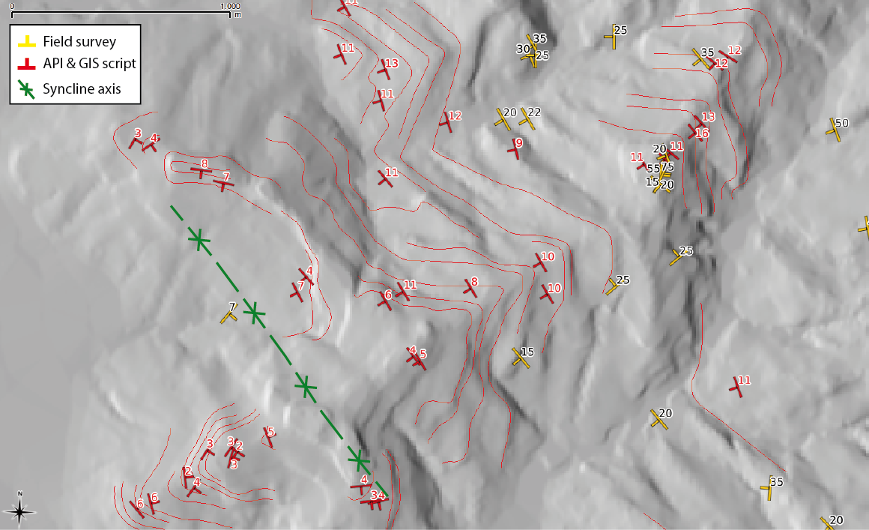
Figure 7 Comparison of the BAs obtained by means of the procedure (red symbols) with data relating to a detailed geological surveys (yellow symbols). In green synclyne axis is drawn. Inclination values are labelled.
Discussion and conclusion
We developed a procedure to obtain bedding attitude data from aerial photo-interpretation using a GRASS GIS script. Advantages of the procedure include: (i) a quantitative estimation of the inclination and dip direction of multiple BTs mapped trough API, (ii) a significant increase in the number of BA features compared to those obtained during field surveys, (iii) the rapid execution of the procedure, compared to long and expensive field surveys, and (iv) the fact that the obtained BA features are not influenced by local anomalies.
BAs obtained exploiting API and the GRASS GIS script are quantitative, distributed geographically, and representative of the dominant geological structures in the study area. Using the proposed method it is possible to obtain a dense spatial distribution of BAs, useful for BAs spatial interpolation (Meentemeyer & Moody, 2000; Günther, 2003; Günther et al., 2004; Ghosh et al., 2010).
The GRASS shell script has not been tested in areas characterized by steeply inclined bedding planes, and is available (http://geomorphology.irpi.cnr.it/tools) under the terms of the GPL licence.

References
Ardizzone F, Cardinali M, Galli M, Guzzetti F, Reichenbach P, (2007) Identification and mapping of recent rainfall-induced landslides using elevation data collected by airborne Lidar. Nat. Hazards Earth Syst. Sci. 7: 637–650.
Butler R F, (1992) Paleomagnetism: Magnetic Domains to Geologic Terranes. Blackwell Scientific Publications – Boston. Oxford. Available online at http://www.geo.arizona.edu/Paleomag/book/.
Cardinali M, Antonini G, Reichenbach P, Guzzetti F, (2001) Photo geological and landslide inventory map for the Upper Tiber River basin. Pubblication CNR GNDCI n. 2116, Scale 1:1,200,000.
Davis JC, (1973) Statistics and data analysis in geology (second edition). John Wiley & sons, New York.
Ghosh S, Günther A, Carranza E J M, van Westen C J and Jetten V G, (2010) Rock slope instability assessment using spatially distributed structural orientation data in Darjeeling Himalaya (India). Earth Surf. Process. Landforms. 35: 1773–1792.
GRASS Development Team, (2010) Geographic Resources Analysis Support System (GRASS) Software, Version 6.4.0. Open Source Geospatial Foundation. http://grass.osgeo.org.
Günther A, (2003) SLOPEMAP: programs for automated mapping of geometrical and kinematical properties of hard rock hill slopes. Computers & Geosciences. 29: 865–875.
Günther A, Carstensen A, Pohl W, (2004) Automated sliding susceptibility mapping of rock slopes. Nat. Hazards Earth Syst. Sci. 4: 95–102.
Guzzetti F, Reichenbach P, Ardizzone F, Cardinali M, Galli M, (2006) Estimating the quality of landslide susceptibility models. Geomorphology. 81: 166-184.
Meentemeyer R K, Moody A, (2000) Automated mapping of conformity between topographic and geological surfaces. Computers & Geosciences. 26: 815-829.
Nichols G, (2009) Sedimentology and stratigraphy - Wiley - Blackwell, ChiChester, UK.
Rowland S M, Duebendorfer E M, (1994) Structural analysis and synthesis: a laboratory course in structural geology. Blackwell Publishing, Malden USA.

