Staircase Falls Rockfall on December 26, 2003 and Geologic Hazards at Curry Village, Yosemite National Park, California

Gerald F. Wieczorek¹, James B. Snyder², James W. Borchers³, & Paola Reichenbach⁴

¹U.S. Geological Survey (email: gwieczor@usgs.gov)

²National Park Service, Yosemite National Park (email: jimsnyder@sbcglobal.net)

³U.S. Geological Survey (email: jborcher@usgs.gov)

⁴Consiglio Nazionale delle Ricerche, Istituto di Ricerca per la Protezione Idrogeologica (email: Paola.Reichenbach@irpi.cnr.it)

Abstract: Since 1857 several hundred rockfalls, rockslides and debris flows have been observed in Yosemite National Park. At 12:45 am on December 26, 2003, a severe winter storm triggered a rockfall west of Glacier Point in Yosemite Valley. Rock debris moved quickly eastward down Staircase Falls toward Curry Village. As the rapidly moving rock mass reached talus at the bottom of Staircase Falls, smaller pieces of flying rock penetrated occupied cabins. Physical characterization of the rockfall site included rockfall volume, joint patterns affecting initial release of rock and the travel path of rockfall, factors affecting weathering and weakening of bedrock, and hydrology affecting slope stability within joints. Although time return intervals are not predictable, a three-dimensional rockfall model was used to assess future rockfall potential and risk. Predictive rockfall and debris-flow methods suggest that landslide hazards beneath these steep cliffs extend further than impact ranges defined from surface talus in Yosemite Valley, leaving some park facilities vulnerable.

Introduction
Since 1857, various types of landslides, particularly rockfalls, rockslides, and debris flows have been observed in Yosemite Valley by many visitors, including Josiah Whitney, the first State Geologist of California; James Hutchings, author and hotel owner in Yosemite; John Muir, noted naturalist; and Joseph LeConte, Professor of Geology at the University of California. More systematic recording of both small and large rockfalls and other types of landslides affecting facilities began after 1916 in the monthly National Park Service (NPS) Superintendent’s reports. The level of rockfall documentation increased beginning in the 1980s with the involvement of the U.S. Geological Survey with the NPS (Wieczorek et al. 1992). Between 1857 and 2004, 14 people have been killed and at least 62 injured by more than 541 landslides that have been documented in Yosemite National Park (Wieczorek and Snyder 2004).
Some landslides in Yosemite have been observed during rain storms, earthquakes, or other natural triggering events. However, most landslides in Yosemite have not been directly observed when they occurred and many of their triggers are unknown. For example, although infiltrating rainfall is not literally observed filling rock joints, time coincidence of storms and rockfall might result from increased groundwater pressure that destabilizes a jointed rock mass. In many cases, even though a rockfall was closely observed, no specific trigger was recognized. For example, on August 6, 1870, Joseph LeConte saw a very large rockfall from Glacier Point but did not observe a storm, earthquake or other trigger (LeConte 1875). During the period of 1857-1992, 54% of landslides had unreported or unrecognized triggers (Wieczorek and Jäger, 1996). Using a 1992 rockfall database (Wieczorek et al. 1992) and hazard assessment (Wieczorek et al. 1999), geologists have tried to achieve a better scientific understanding of Yosemite landslide failures by more detailed study of individual events.
Near Glacier Point in Yosemite Valley (Fig. 1), as many as 58 rock falls, rockslides and debris flows were recorded between 1870 and 2004, some of which have adversely affected infrastructure at Curry Village. The December 26, 2003, Staircase Falls rockfall provided the impetus to assess information from those earlier studies and provide a composite view of general conclusions about geohazards around Glacier Point as well as the usefulness of predictive rockfall and debris-flow models.

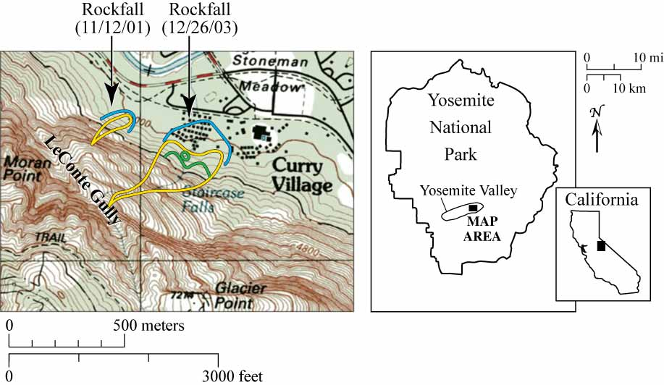

Figure 1. Topographic map of Glacier Point-Curry Village in Yosemite Valley, California with two rockfalls from Staircase Falls into Curry Village. Yellow lines show the initial release, travel track, and continuous rock debris deposit region. The green line depicts where trees were knocked down and the blue lines show the limit of flyrock.

DECEMBER 26, 2003, STAIRCASE FALLS ROCKFALL
Between Dec. 24 and 26, 2003, an intense storm dropped 105 mm of rain as well as snow which caused freezing at higher elevations. This storm triggered at least three rockfalls or rockslides in Yosemite Valley (Wieczorek and Snyder, 2004). At about 12:45 am on December 26, a rockfall initiated west of Glacier Point above the upper portion of Staircase Falls on the eastern edge of LeConte Gully (Figs. 1, 2). The rockfall quickly free-fell about 20 m onto discontinuity controlled rock surfaces related to joint set J2 (Table 1) and then continued northeast about 745 m downslope to the base of Staircase Falls. The impact of the rock debris onto the talus slope at the base of Staircase Falls generated flying or airborne rock that extended well into a developed portion of Curry Village (Fig. 1). These airborne rocks have been called flyrock by Wieczorek and Snyder (1999). Beyond the base of the rockfall talus deposit, several distinct impact areas of fist-sized and larger pieces of fresh rock were recognized as flyrock that had been thrown up to 75 m north and had struck occupied visitor cabins (Fig. 1).
By 12:50 am on Dec. 26, emergency 911 calls from Curry Village reported people trapped and yelling for help. Immediate response by the NPS and Delaware North Corporation personnel found that fourteen duplex cabin units were hit by flyrock and two other units were splattered with mud when flyrock landed nearby. Darkness and snow made it difficult to track the extent of the flyrock. By 2:25 am, 66 cabin units had been evacuated and four people treated for minor cuts and scratches. By 3:29 am, 33 more units were evacuated. When daylight came and better visibility improved assessment capabilities, 34 more duplex units were closed. A fresh cover of snow on the ground limited precise determinations of the full extent and patterns of talus and flyrock. About 100 people were relocated out of Curry Village for the remainder of the night.

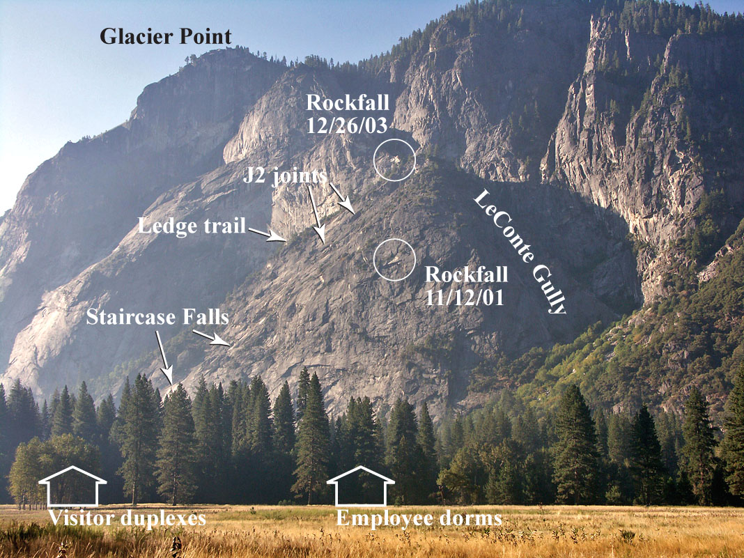

Figure 2. Glacier Point with Staircase Falls and abandoned Ledge Trail along eastward dipping J2 joint sets and site of Dec. 26, 2003 and Nov. 12, 2001 rockfalls. The cliff faces exhibit the influence of vertical regional joints weathered back along J1 exfoliation joints (Photo by Greg Stock, NPS, 2006).

GLACIATION AND WEATHERING
The eastern portion of Yosemite Valley was deepened and broadened during several episodes of glacial erosion (Huber 1987). The latest (Tioga) glacial advance peaked between about 28,000 and 17,000 y BP and did not fill the valley (Bursik and Gillespie 1993). The Dec. 26 Staircase Falls rockfall originated at about 1768 m elevation on the edge of LeConte Gully and on the upper northeast side of a small weathered fin around which Staircase Creek has to turn sharply out of the gully to reach the top of its falls. Bedrock at the release site, upslope from the maximum level of the Tioga glaciation (Matthes 1930 pl. 29; Wieczorek et al. 1999), has been weathering since the Sherwin glaciation overtopped Yosemite Valley’s walls one million years ago (Smith et al. 1983). Above the Tioga glacial trimline, the cliffs have weathered and joints have opened allowing water to infiltrate and ice to wedge open near surface joints. Weathering is accelerated and weathered rock zones are thickest where granitic rocks are most frequently wet.
The bedrock geology of the Yosemite Valley consists of several different types and ages of granitic materials, principally including Cretaceous granite, granodiorite, quartz monzodiorite, and quartz diorite (Huber et al. 1989). The rocks in the mountainous area of Glacier Point and Staircase Falls are primarily Late Cretaceous Sentinel or Glacier Point Granodiorite and Half Dome Granodiorite. Resting on these units at the base of Curry Village are Quaternary alluvium and talus (Calkins 1985 and Peck 2002). Even though there is a contact between Glacier Point and Half Dome Granodiorites in the Staircase release area, there is no clear correlation between rock type, jointing or weathering patterns.

JOINTING AND WEATHERING
As many as 13 joint sets (J1-J13) have been identified in the Glacier Point region (Table 1) and labeled following the methodology used to describe joint sets near the 1998-99 Curry Village rockfall release (Wieczorek and Snyder 1999). Regional-scale joints (J3, J7, J10 and J11), visible on satellite imagery (USGS, 1986), may dominate the ground-water-flow system near Glacier Point. Glacier Point and Half Dome cliff faces as well as LeConte Gully are controlled by these joints which intersect nearly all others. Joint (J2) is a pervasive ledge-forming discontinuity with steep dips of about 30 degrees to the east below Glacier Point. This orientation is similar to the set of discontinuities that form the stair treads of Staircase Falls and the broad ledge carrying the abandoned “Ledge Trail” (Fig. 2), which begins above Curry Village and extends westward towards LeConte Gully. The third kind of joints are exfoliation joints (J1), parallel to topographic surfaces, which have influenced erosion back from the original controlling joint surfaces exposing the inclined steps of Staircase Falls (Huber 1987).
The intersection of joints along a slope can be analyzed to determine whether rockfalls, slides or topples are likely. A joint or exfoliation sheet parallel to the cliff also can be responsible for a collapse. For example, the release area for a rockfall of 563 m³ that occurred on Nov. 16, 1998, above the eastern part of Curry Village contained intersecting joints J2 through J6, but none of these joint planes or joint plane intersections formed plane or wedge conditions favorable for sliding or toppling because the direction and inclination of the cliff face was not optimally oriented for sliding or toppling. The joints and their intersections at the release points define the top and lateral boundaries of an exfoliation sheet section that released the rockfall. Thus, although joint sets J2 through J6 did not form the surface along which sliding occurred, they did determine the size of exfoliation sheet segments that failed (Wieczorek and Snyder 1999).
About 204 m³ fell during the Dec. 26, 2003 Staircase Falls rockfall. Part of the failed rock traveled northeast down the major J2 east-trending joints that reached the bottom of Staircase Falls and sent flyrock into the Camp Curry duplexes (Fig. 1). Measurements of 25 joints near the Staircase release along LeConte Gully above Staircase Falls identified 19 joints of major joint sets (J6, J9, J13). Assuming a static friction strength of at least 35 degrees for granitic rock and evaluating the initial slope dipping northeast at about 60 degrees from the site of the rockfall collapse with each of the three major joints and possible joint intersections suggests that only the north dipping J9 joint with an average dip of 53 degrees to the north could have detached the mass of rock. Nearly all these joints in the thin fin of granitic rock between LeConte Gully and Staircase Falls were thoroughly weathered from long post-glacial exposure. Only a few feet of weathered granitic rock separates Staircase Creek in the gully from the cliff face of the Staircase release. The weathered joints are conduits for water infiltrated at the creek and moving through the weathered rock to the release site.

Table 1. Joint systems in Glacier Point region. J1 represents sheeting joints produced by exfoliation paralleling the topographic surface. More joints exist than were measured. Trend, Plunge, Strike, and Dip are measured in degrees.

ID# | ID direction | # Joints | Trend | Plunge | Strike | Dip
J1 | Parallel to topographic surface
J2 | NE | 20 | 78.8 | 28.8 | 168.8 | 28.8E
J3 | NE vertical | 18 | 69.4 | 86.5 | 159.4 | 86.5E
J4 | NE flat | 7 | 79.0 | 14.4 | 169.0 | 14.4E
J5 | W flat | 4 | 263.4 | 20.0 | 173.4 | 20.0W
J6 | SW | 35 | 240.9 | 51.5 | 150.9 | 51.5SW
J7 | W vertical | 13 | 256.6 | 82.3 | 166.9 | 82.3W
J8 | SE | 19 | 127.1 | 42.1 | 37.1 | 42.1SE
J9 | NW | 17 | 324.6 | 53.5 | 54.6 | 53.5NW
J10 | N vertical | 17 | 355.4 | 82.8 | 85.4 | 82.8N
J11 | SE vertical | 19 | 163.1 | 85.3 | 73.1 | 85.3S
J12 | NW steep | 9 | 321.7 | 78.6 | 51.6 | 78.6NW
J13 | S flat | 8 | 191.2 | 21.6 | 101.2 | 21.6S

HYDROLOGY AND WEATHERING
Quantitative hydrologic characterization of the subsurface at Glacier Point is severely limited by access. Some understanding of subsurface hydrology at Glacier Point was based on examination of precipitation, spring flow, cliff seepage, stream flow and water use data at Glacier Point visitor facilities based on application of hydrologic principles (James Borchers 2005, written communication) and from knowledge of subsurface hydrologic investigations at Wawona, Yosemite National Park and elsewhere in granitic rocks (Borchers 1996). Overburden depth can affect spacing and openness of joints, particularly J1 joints that form roughly parallel to the cliff surface. Along Glacier Point cliffs joints widen and can be more transmissive than deeper below land surface where rock pressure can squeeze fractures closed and restrict flow of water. Because most precipitation at Glacier Point is snow, water in Glacier Point joints primarily is recharged from snowmelt. The effects of that natural precipitation on rockfall cannot be precisely determined because a large percentage of recorded rockfalls have occurred with unrecognized triggers. Storms correlate well with many other rockfalls (Wieczorek and Snyder 2004). Staircase Creek gains flows from groundwater discharging to the stream channel between the Glacier Point parking lot and Staircase Falls (James Borchers 2005, written communication). However, just upstream from the point where Staircase Falls leaves LeConte Gully and turns to the northeast to form Staircase Falls stream, water infiltrates the channel and moves through fractures in the fin of weathered decomposed granitic rock separating gully from Staircase Falls. Water discharging from the release area is adequate to support wetland vegetation growing on the cliff below the release area year round. Photographs of the Staircase release area show that the block that failed on Dec. 26, 2003, had moisture streaming from joints (Fig. 3). Earlier rockfall from that release area had cut a path through the trees. Each failure from the face of the cliff at the release site makes the weathered fin between LeConte Gully and Staircase Falls thinner, allows increased flows from Staircase Creek and permits winter ice to form deeper into the cliff face. Each failure there accelerates joint weathering processes, thereby reducing return intervals for future rockfalls from this location
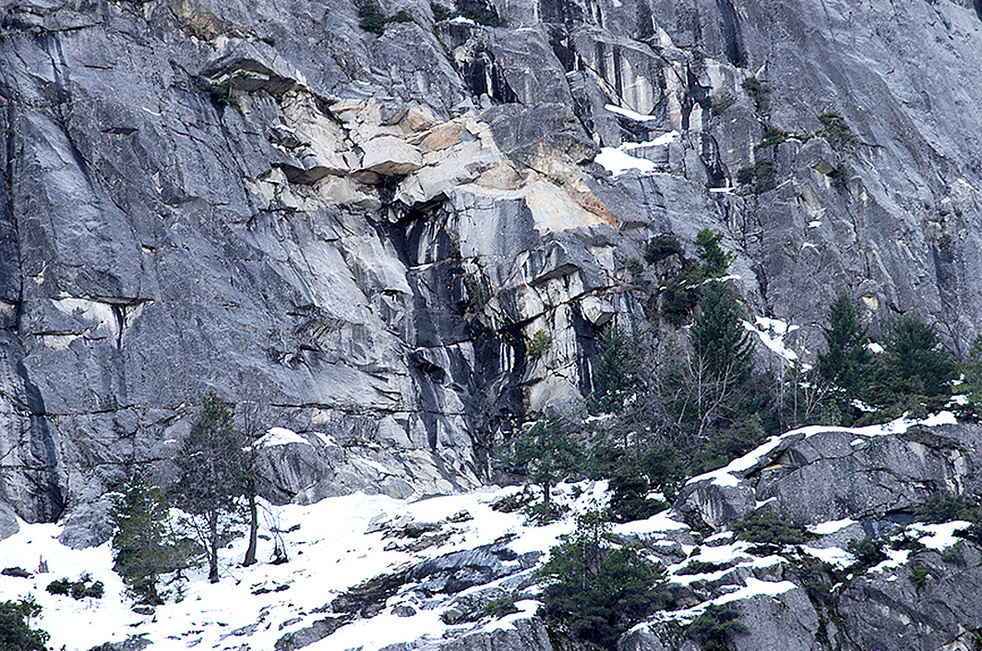
Figure 3. December 26, 2003 Staircase Falls rockfall release site with fresh light colored joints and impact area and large ledge covered with snow at the top of Staircase Falls. Note the heavy dark drainage paths extending down from the release and former roof (Photo by Dan Horner, NPS, January, 2004).

HAZARD AND RISK ASSESSMENT
Not all rockfall material from the Staircase Creek release area has gone over Staircase Falls to the floor of Yosemite Valley. About 842 m³ of loose rock and debris has accumulated below the release area on slickrock ledges sloped at 35 to 40° toward the west end of Curry Village. Seepage from the weathered Staircase Falls release area has continued to wash soil, rock, and vegetation over the falls. Further weakening of the thin wall of LeConte Gully will increase seepage through this debris and could move it more quickly toward the lip of the falls and Curry Village below.
This potential rockfall hazard was underestimated when the USGS developed a map of rockfall potential in Yosemite Valley to support the NPS Yosemite Valley Plan (Wieczorek et al. 1999). Rockfalls were also more systematically examined than debris flows. Because little subsurface geological investigation has been done in Yosemite Valley, rockfall potential was mapped on the basis of recorded rockfall deposits and surface evidence of talus and scattered outlying boulders beyond the talus slopes at the base of cliffs. To compensate for the lack of subsurface data on the valleyward extent of rockfall, the angle extending horizontally from the apex of the talus slope to the farthest outlying boulder (Fig. 4) was used to determine the limits of rockfall shadow where infrequent rockfall events may stop (Evans and Hungr 1993). The map has one line along the foot of visible talus at the base of the talus slopes and a shadow line drawn from a minimum shadow angle of 22° beyond the talus (Fig. 4). This line did not apply to some large debris flows, large rock avalanche runout distances, potential airblast area, or potential flyrock ranges (Wieczorek et al. 1999). Rockfall impact areas including flyrock were mapped not only for safety around facilities but to see how actual events of different sizes and characters correlated with the map of potential failures.
The extent of areas potentially subject to rockfall hazards was also assessed by using STONE, a topographically based rockfall simulation computer program using Digital Elevation Model (DEM) (Guzzetti et al. 2002). Whereas other models typically generate two dimensional rockfall trajectories, STONE can generate the three dimensional rockfall trajectories over a range of rock volumes. The STONE model has previously been used to investigate rockfalls in Yosemite Valley (Guzzetti et al. 2003). Applying the STONE model to two rockfalls near Staircase Falls-Curry Village, Nov. 12, 2001 and Dec. 26, 2003, the simulated and actual rockfall trajectories can be compared (Fig. 5). Although the predicted travel direction for the smaller Nov. 12 rockfall did not exactly match the mapped rockfall, the trajectory simulated for the larger Dec. 26 rockfall was close to the field mapping. Though flyrock is not included in the STONE model, the model indicates the potential for rocks to travel even further than recorded from these specific releases. The STONE model suggests that travel distance is directly related to rockfall volume; that is, larger volumes may travel further.
The STONE model does not evaluate debris flows, and the map of rockfall potential did not address the area directly beneath the Staircase release in enough detail when new dormitories were planned and built. Furthermore, there were few recorded rockfalls or debris flows in the inventory for the west Curry Village area before the Christmas 2003 events. Simultaneous with the Dec. 26 Staircase rockfall, a small debris flow from LeConte Gully entered the proposed dorm area. Though there are notable exceptions, most debris flows occur between late fall and early spring, because that is the time of greatest ground saturation. Debris flows can be initiated by heavy storms but also by rockfall or avalanche onto saturated slopes. The Dec. 1937 flood initiated debris flows from both Staircase Falls and LeConte Gully. The Staircase Falls debris flow filled the Staircase creek channel with “huge boulders,” piled rock and debris against cabin walls and broke through into the cabins. In Feb. 18, 1986, a debris flow of rock and mud extended through Curry Village burying one residence and the uppermost Curry Village shower house with up to four feet of debris (Wieczorek and Snyder 2004). The shower house was rebuilt as a result of debris flow damage, and a diversion wall of large rock was built in the channel behind the new shower house to protect it.
Subsurface trenching in the proposed dormitory area indicated that unrecorded debris flows and flyrock from rockfall reached the dorm area (Fig. 2) and noted that a stream channel mapped in 1934 had been filled by a debris flow (Norman and Gates 2005). Other evidence of rockfall into the shadow zone appeared when excavations for dorm building foundations encountered a 15-foot long boulder two feet under the surface and again when tons of flyrock and rockfall boulders were removed for building foundations. On Oct. 25, 2005, a rockfall from the cliffs above sent flyrock well into the new dorm during construction with only one minor injury. Numerical modelling of debris flows has been compared with documented historic debris flow events in Yosemite Valley, providing a debris flow model to accompany the STONE model for rockfall (Bertolo and Wieczorek 2005). The potential for debris flows to damage facilities in the proposed Curry Village dormitory area appears to be fairly high; however, dormitory planning, contracting, and construction schedules could not accommodate the slowly accumulating evidence from models, field work, and landslide events of potential hazards.

Figure 4. Sketch of rockfall talus at base of slope and outlying boulders illustrating the limit of the rockfall shadow angle (Wieczorek et al. 1999).
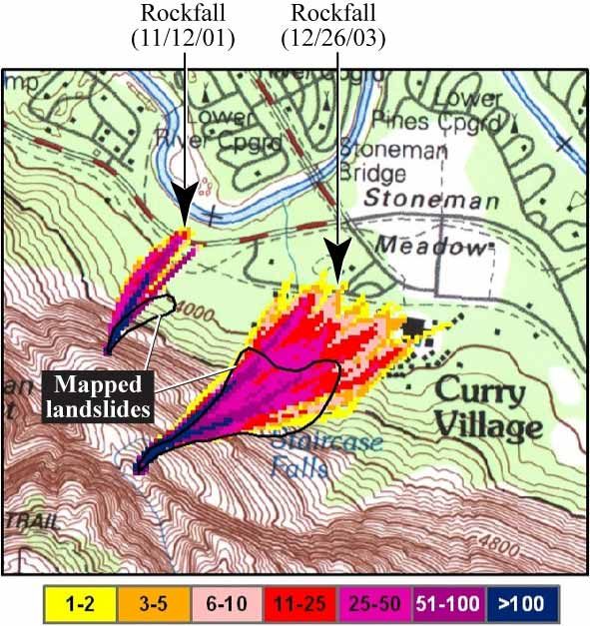
Figure 5. Comparison between the mapped landslides (thick black lines) and the simulated rock falls for the Nov. 12, 2001 event (left) and the Dec. 26, 2003 event (right). Colors show the number of rockfall trajectories.

CONCLUSIONS
Analysis of numerous historic landslides in Yosemite National Park has indicated that unpredictable landslides might occur in many regions, especially within Curry Village in Yosemite Valley. Geologic conditions including post glacial weakening of bedrock, joint spacing and orientation within cliffs, and groundwater infiltration and pore pressure development from cold weather conditions have influenced the triggering of rockfalls, rockslides, and debris flows. Examination of recent landslides and subsurface trenches in the western section of Curry Village has indicated that in some places landslide deposits extend further than the current talus slopes above Curry Village, thus facilities are more vulnerable to landslide hazards than originally assumed.

Acknowledgements: Jim Snyder conducted the major field examination of the December 26, 2003 Staircase Falls rockfall. Jim Borchers examined the conditions of water influence on joints in the Glacier Point region. Paola Reichenbach conducted the STONE models of rockfall from specific release points below Glacier Point. David Jones of the USGS modified and improved the detailed figures. Greg Stock of NPS and Tom Holzer of USGS conducted a preliminary review of the document.

Corresponding author: Gerald F. Wieczorek, USGS, 345 Middlefield Rd., MS 910, Menlo Park, CA 94025, USA. Tel: 650-329-5251. Email: gwieczor@usgs.gov.

REFERENCES
BERTOLO, P. & WIECZOREK, G.F. 2005. Calibration of numerical models for small debris flows in Yosemite Valley, California, USA: European Geophysical Union-Natural Hazards and Earth System Sciences, 5, 993-1001.
BORCHERS, J.W. 1996. Ground-water resources and water-supply alternatives in the Wawona area of Yosemite National Park, California: U.S. Geological Survey, Water-Resources Investigations Report 95-4229.
BURSIK, M.I. & GILLESPIE, A.R. 1993. Late Pleistocene glaciation of Mono Basin, California: Quaternary Research, 39, 24-35.
CALKINS, F.C. 1985. Bedrock geologic map of Yosemite Valley, Yosemite National Park, California, with accompanying pamphlet by Huber, N.K. and Roller, J.A.: U.S. Geological Survey Miscellaneous Investigations Series Map I-1639.
EVANS, S.G. & HUNGR, O. 1993. The assessment of rockfall hazard at the base of talus slopes, Canadian Geotechnical Journal, 30, 620-636.
GUZZETTI, F., CROSTA, G., DETTI, R. & AGLIARDI, F. 2002. STONE: a computer program for the three-dimensional simulation of rock-falls, Computers and Geosciences, 28, 9, 1079–1093.
GUZZETTI, F., REICHENBACH, P. & WIECZOREK, G.F. 2003. Rockfall hazard and risk assessment in the Yosemite Valley, California, USA: Natural Hazards and Earth System Sciences, European Geophysics Union, 3, 491-503.
HUBER, N.K. 1987. The geologic story of Yosemite National Park, U.S. Geological Survey Bulletin 1595.
HUBER, N.K., BATEMAN, P.C. & WARHAFTIG, C. 1989. Geologic Map of Yosemite National Park and Vicinity, California, U.S. Geologic Survey Miscellaneous Investigations Series Map I-1874.
LE CONTE, J. 1875. A journal of ramblings through the High Sierras of California: San Francisco, Francis & Valentine.
MATTHES, F.E. 1930. Geologic history of the Yosemite Valley: U.S. Geological Survey Professional Paper 160.
NORMAN, D. & GATES, W.C.B. 2005. Limited debris flow assessment at the proposed employee housing, Curry Village, Yosemite National Park: Kleinfelder, Inc. for NPS, Yosemite National Park, Job. No. 47022.
PECK, D.L. 2002. Geologic map of the Yosemite quadrangle, central Sierra Nevada, California: U.S. Geological Survey Geologic Investigations Series Map I-2751.
SMITH, G.I., BARCZAK, V.J., MOULTON, G.F. & LIDDICOAT, J.D. 1983. Core KM-3, a Surface-to-Bedrock Record of Late Cretaceous Sedimentation in Searles Valley, California: U.S. Geological Survey Professional Paper 1256.
U.S. GEOLOGICAL SURVEY. 1986. Satellite Orthoimage of Yosemite Valley, Yosemite National Park, California, Mariposa County, Experimental Edition, scale 1:24,000.
WIECZOREK, G.F. & JAGER, S. 1996. Triggering mechanisms and depositional rates of postglacial slope-movement processes in the Yosemite Valley, California, Geomorphology, 15, 17-31.
WIECZOREK, G.F. & SNYDER, J.B. 1999. Rock falls from Glacier Point above Camp Curry, Yosemite National Park, California: U.S. Geological Survey Open-file Report 99-385.
WIECZOREK, G.F. & SNYDER, J.B. 2004. Historical rock falls in Yosemite National Park: U.S. Geological Survey Open-File Report 03-491.
WIECZOREK, G.F., SNYDER, J.B., ALGER, C.S. & ISAACSON, K.A. 1992. Rock falls in Yosemite Valley, California: U.S. Geological Survey Open-File Report 92-387.
WIECZOREK, G.F., MORRISSEY, M.M., IOVINE, G. & GODT, J. 1999. Rock-fall potential in the Yosemite Valley, California: U.S. Geological Survey Open File Report 99-578.

